**Assignment 2.1**

**Task 1**

Check whether /user/acadgild directory exists or not in the HDFS.

If it doesn't exist, then create this.

**hadoop fs -ls /user/acadgild**

Create a directory /user/acadgild/hadoop.

**hadoop fs -mkdir user/acadgild/hadoop**

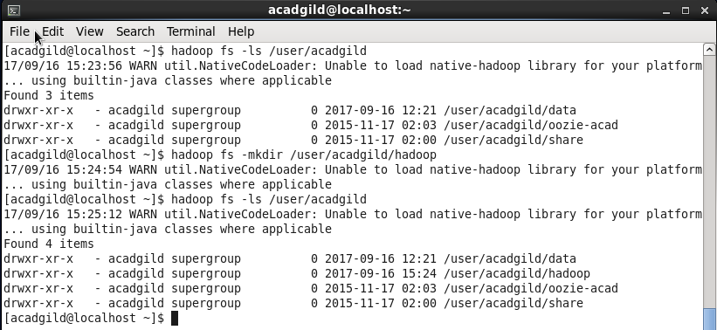

**Task 2**

Create a file in HDFS under directory /user/acadgild/hadoop, with name word-count.txt.

**hadoop fs -touchz /user/acadgild/hadoop/word-count.txt**

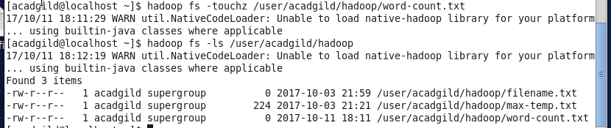

Whatever we type on screen should get appended to the file.

Try to type (on screen) few lines from any online article or textbook.

**cat |hadoop fs -appendToFile - /user/acadgild/hadoop/word-count.txt**

